SME to walk through the following aspects related to the project created:

- src/main/java - Folder with application code:

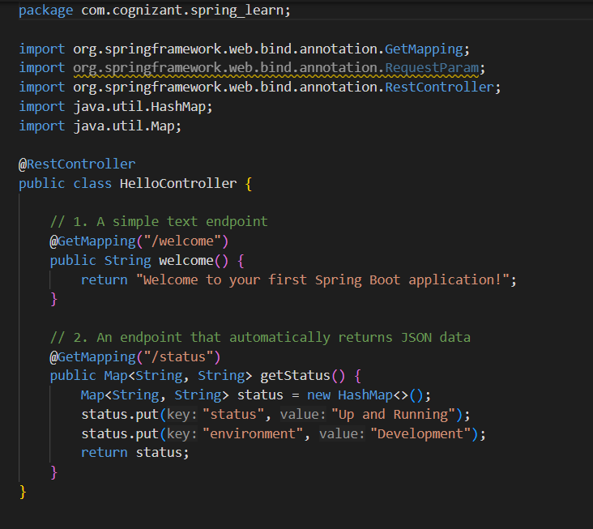
- src/main/resources - Folder for application configuration:
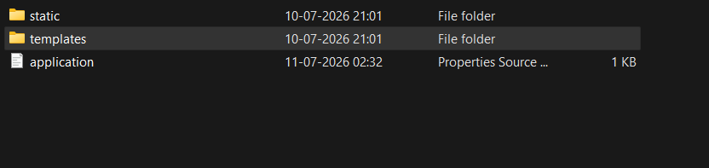

- src/ test/ java – folder with code for testing:
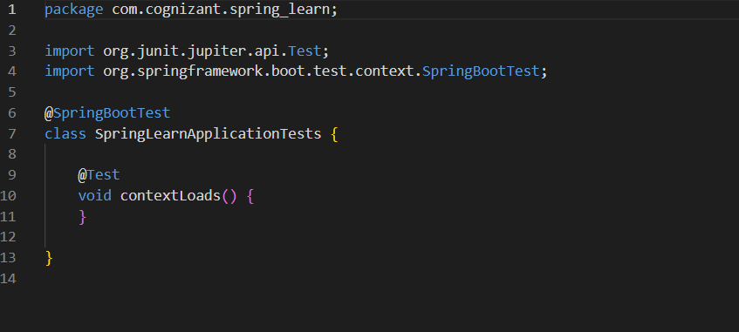

- SpringLearnApplication.java - Walkthrough the main() method.
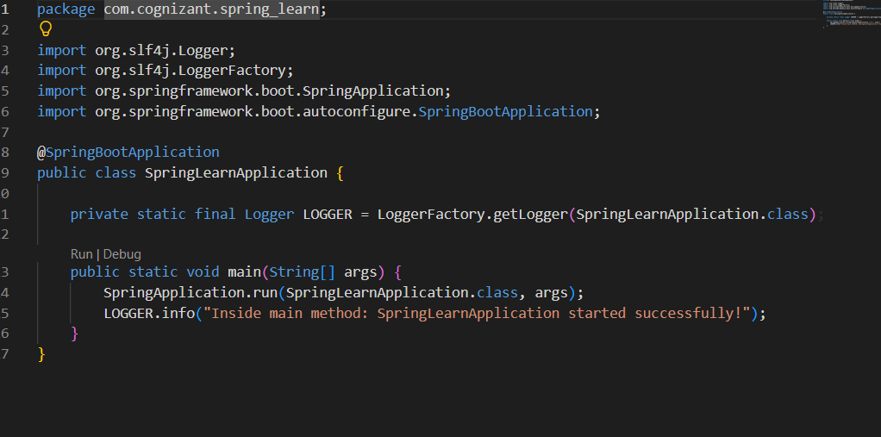

- Purpose of @SpringBootApplication annotation
Annotation | What it does
@SpringBootConfiguration | A specialized version of @Configuration. It marks this class as a source of bean definitions for the application context.
@EnableAutoConfiguration | The "magic" of Spring Boot. It tells the framework to scan your project's classpath dependencies and automatically configure sensible defaults. Example: Since spring-boot-starter-web is on your classpath, it automatically configures an embedded Tomcat server and sets up Jackson for JSON parsing.
@ComponentScan | Instructs Spring to search the current package (com.cognizant.springlearn) and all of its sub-packages for managed components (such as @Component, @RestController, @Service, or @Repository) and register them as Beans in the container.

6. pom.xml Walkthrough
6.1 Configuration Defined in the XML File
- <parent>: Inheriting from spring-boot-starter-parent acts as your project's Bill of Materials (BOM). It manages version control for dozens of matching dependencies so you don't have to manually specify version tags for every library.
- <dependencies>:
  - spring-boot-starter-web: Pulls in core Spring MVC libraries and the embedded Tomcat engine.
  - spring-boot-devtools: Enables fast application restarts and live reload capacities during active development.
- <build>: Declares the spring-boot-maven-plugin. This plugin packages your entire compiled application alongside its embedded dependencies into a single, executable "fat" JAR file.
6.2 The Dependency Hierarchy Tree
While your pom.xml only explicitly names a couple of core starter dependencies, Maven relies on Transitive Dependencies (dependencies of dependencies).
To view the dependency tree in VS Code:
- Look at your bottom-left sidebar panel and expand the MAVEN tab.
- Expand spring-learn $→$ Dependencies.
- You will see the expanded tree structure showing exactly how declaring spring-boot-starter-web silently pulled in all necessary foundational jars:
spring-learn [jar]
└── Dependencies
└── spring-boot-starter-web
├── spring-boot-starter
├── spring-boot-starter-json
│ └── jackson-databind (Converts objects to JSON)
├── spring-boot-starter-tomcat (Embedded Web Server)
├── spring-web
└── spring-webmvc (Handles routing & REST Controllers)

